Remote controlled switch circuit

In this project, let’s build a simple Remote controlled switch for appliance controlling. If you know basic concepts of electronics, this circuit is pretty easy to build and test. The core of this circuit are two IC’s – which are infra red sensor IC’s – TSOP 1738. A couple of transistors and associated components complete the circuit – which is affordable for any hobbyist/student.

Working:
IR remote sensor IC TSOP 1738 is used for receiving the signal. Normally when no signal is falling on IC3 the output of it will be high. This makes Q1 OFF.When a signal of 38 KHz from the TV remote falls on the IC3 its output goes low.This makes Q1 conduct and a negative pulse is obtained at pin 2 of IC 1 NE 555. Due to this IC1 wired as a monostable multivibrator produces a 4 Sec long high signal at its out put.This high out put is the clock for IC 2 which is wired as a Flipflop and of , its two outputs pin 3 goes low and pin 2 goes high. The high output at pin 2 is amplified to drive the relay. For the next signal the outputs of IC2 toggles state. Result, we get a relay toggling on each press on the remote. Any appliance connected to this circuit can be switched ON or OFF.

Circuit Diagram:
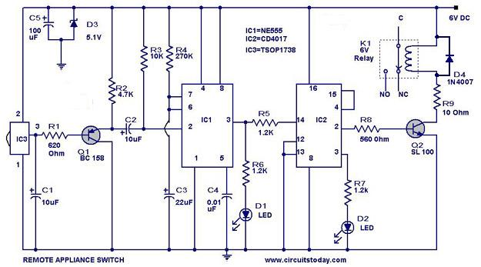

Source: http://www.circuitstoday.com/remote-controlled-appliance-switch-circuit

